**LTVIP2025TMID32454Ideation Phase**

**Define the Problem Statements**

|  |  |
| --- | --- |
| Date | 3 June 2025 |
| Team ID | LTVIP2025TMID32454 |
| Project Name | Clean Tech:Transforming Waste Management with Transfer learning |
| Maximum Marks | 2 Marks |

**Customer Problem Statement Template:**

Create a problem statement to understand your customer's point of view. The Customer Problem Statement template helps you focus on what matters to create experiences people will love.

A well-articulated customer problem statement allows you and your team to find the ideal solution for the challenges your customers face. Throughout the process, you’ll also be able to empathize with your customers, which helps you better understand how they perceive your product or service.

Reference: <https://miro.com/templates/customer-problem-statement/>

**Example:**

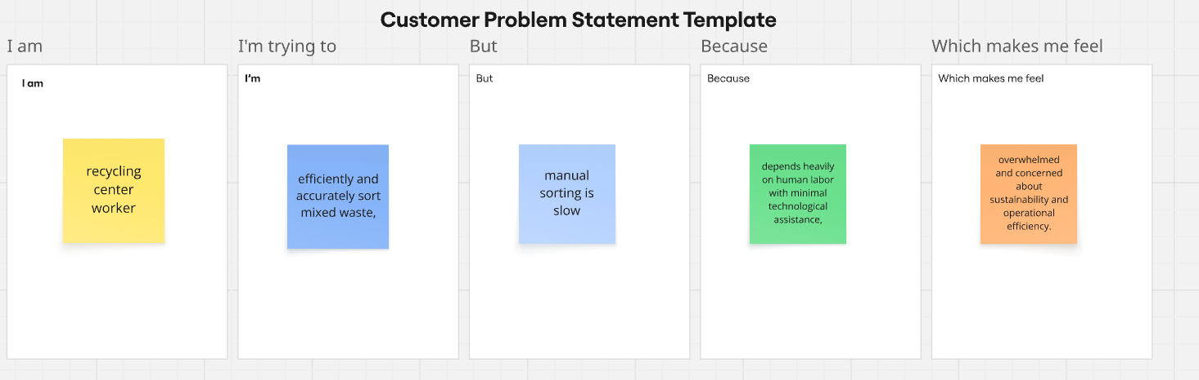

|  |  |  |  |  |  |
| --- | --- | --- | --- | --- | --- |
| **Problem Statement (PS)** | **I am (Customer)** | **I’m trying to** | **But** | **Because** | **Which makes me feel** |
| PS-1 | **I’m trying to** efficiently and accurately sort mixed waste | **But** manual sorting is slow, error-prone, and physically demanding | **Because** the process depends heavily on human labor with minimal technological assistance | **Because** the process depends heavily on human labor with minimal technological assistance | **Which makes me feel** overwhelmed and concerned about sustainability and operational efficiency. |
| PS-2 | **I am** a municipal waste authority or city planner | • **I’m trying to** ensure residents dispose of waste correctly in public bins,  • | **But** improper segregation leads to contamination of recyclables and increases waste processing costs | **Because** there’s no real-time system to guide or correct waste disposal behavior, | **Which makes me feel** frustrated by the lack of compliance and the inefficiency of current systems |